Reservation Form (check one) Exhibitor Table □ Dinner Table □ Both □
Company Name | Ph: ( cell )
Contact | email
Address
City/ State/zip
Dinner tickets qty
Expo Tables will be reserved on a first come first serve basis. There will be 25 exhibit tables at this event. 8’ tables at $495 each. AC power for the exhibitor is limited to 110 VAC, 5A. Two dinner tickets are included with the price of the exhibit table. Exhibitor’s name and website will be listed as a sponsor on the So. CT ASIS website for 1 year. Dinner tables $600 for table of 10, $300 for table of 5 and $65 individual ticket. To Reserve an Expo Table, Dinner Table or Individual dinner ticket use PayPal online at http://www.asis-southernct.com/ or send check payable to : SO. CT ASIS Chapter and mail to address below or Call 203 257 2570 to select exhibit table number.
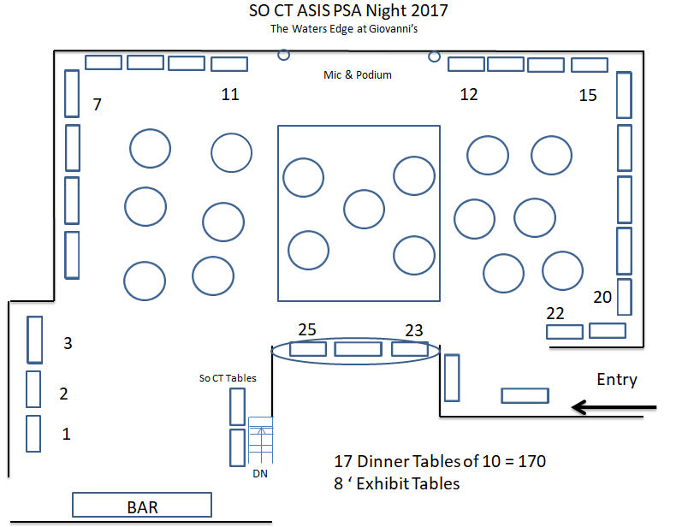

Mark you calendar….. An event you cannot afford to miss
If mailing form send to:
So. CT ASIS PSA Night 2017, PO Box 4082 , Danbury, CT 06813

